Lesson 06 Demo 6
Set up Terraform
Objective: To install and set up Terraform in your local system.
Steps to be performed:
- Download the appropriate package
- Add the binary file to the bin directory

Step 1: Download the appropriate package

1.1 Create a folder

mkdir test
cd test

1.2 Run the following command to download the appropriate package
wget https://releases.hashicorp.com/terraform/0.14.9/terraform_0.14.9_linux_amd64.zip

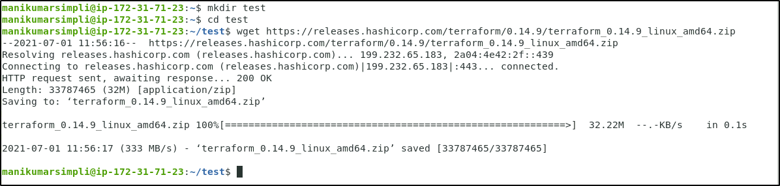

Step 2: Add the binary file into the bin directory

2.1 Run the below set of commands to download, unzip, and move the terraform binary file to the bin directory:

sudo apt-get install unzip
unzip <YourTerraformFileName>.zip
sudo su
mv <YourUnzippedTerraformFileName> /usr/local/bin
cd ..
terraform -version

